BLINKIT DATA ANALYSIS

SQL Querry Script
1.Check all the data is imported
select * from blinkit_data;
2. Data Cleaning: Cleaning the Item_Fat_Content field ensures data consistency and accuracy in analysis. The presence of multiple variations of the same category (e.g., LF, low fat vs. Low Fat) can cause issues in reporting, aggregations, and filtering. By standardizing these values, we improve data quality, making it easier to generate insights and maintain uniformity in our datasets.

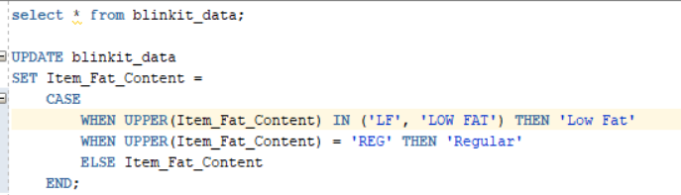
3.Query to check the data has been cleaned or not .
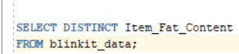
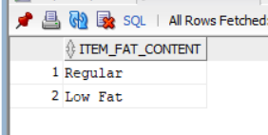

4. A)Find the KPIs:
- TOTAL SALES:
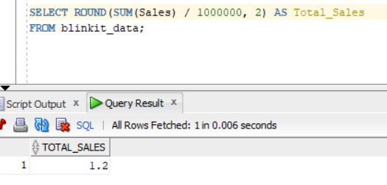
- AVERAGE SALES
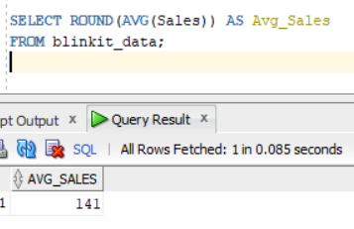

- NO OF ITEMS
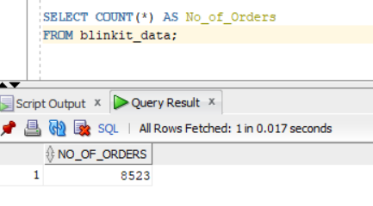

- AVG RATING

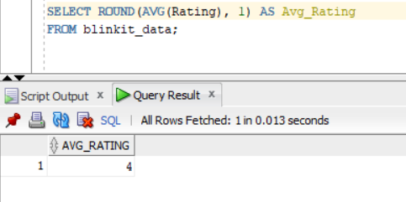

B. Total Sales by Fat Content:

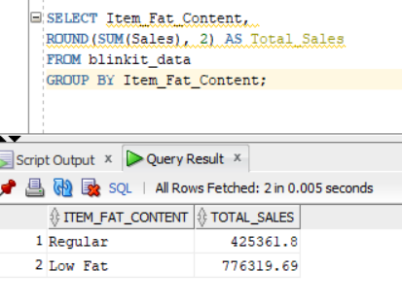
C. Total Sales by Item Type
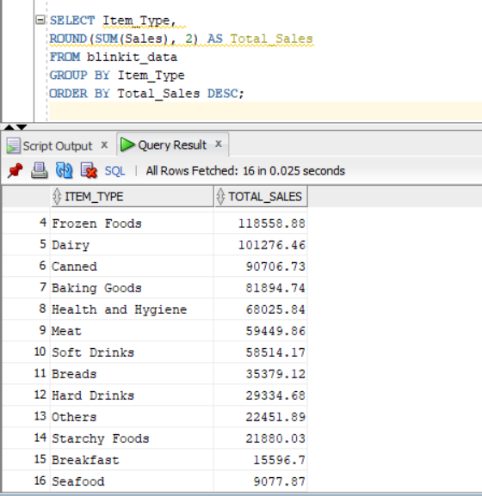

D. Fat Content by Outlet for Total Sales

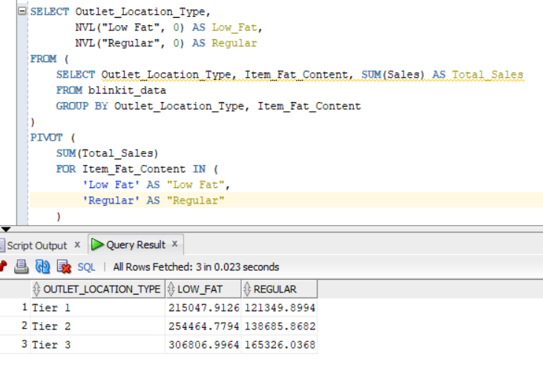E. Total Sales by Outlet Establishment
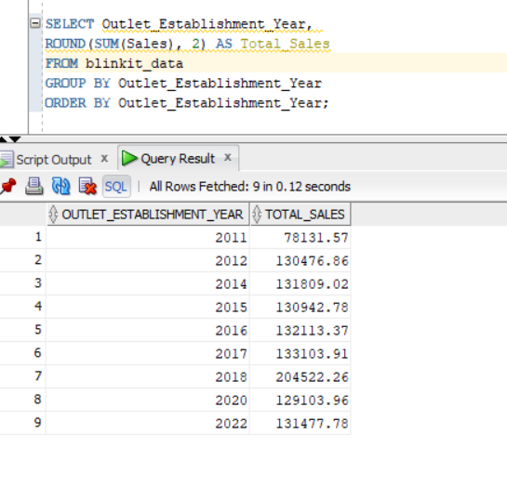
F. Percentage of Sales by Outlet Size
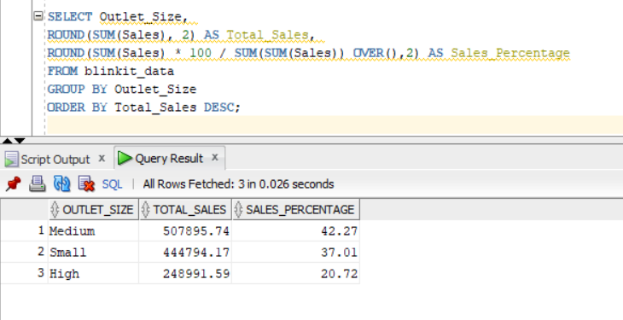
G. Sales by Outlet Location:
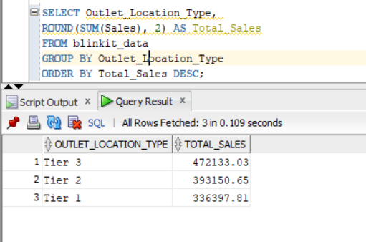
H. All Metrics by Outlet Type:
